**JIRA**

**Understanding Jira for Users, Managers and Admins**

**Section 1: Jira for Managers and Team Leaders:**

1. **Introduction to Jira for Managers Section:**

**Summary of Section Introduction: JIRA for Team Leaders and Managers**

This transcript introduces a specialized section of the course aimed at **Team Leaders and Managers**, focusing on how to manage and customize their projects within Jira without constant reliance on a global Jira Administrator.

**Core Context and Prerequisite**

* **Foundation:** This section builds upon the knowledge acquired in previous parts of the course. *(Extra Point: Prior knowledge of basic Jira navigation, issue types, and project structure is highly recommended.)*
* **Target Audience:** Team Leaders and Managers.
* **The Manager's Role in Jira (The *Permission* Requirement):**
  + By default, managers do **not** have special administrative permissions in Jira.
  + In a real-world context, managers frequently need to control their own projects, boards, and teams without waiting for the global Jira Administrator.
  + **Crucial Setup:** To enable this level of control, all lessons in this section will be conducted while logged in as a user who has **administrator permissions over a single project**. *(Extra Point: This is typically achieved by assigning the manager to the "Project Administrator" role, which grants control over project settings, workflows, and boards without affecting the entire Jira instance.)*

**Key Topics Covered in This Section**

The following points outline the essential features and skills a leader/manager will acquire:

1. **Team and Dashboard Setup:**
   * Learn how to set up core Jira features like **Teams** to organize people and **Dashboards** to provide a single, informative view of team progress.
2. **Board Management and Customization:**
   * In-depth coverage of creating and customizing both **Scrum** and **Kanban** boards.
3. **Day-to-Day Workflow Optimization:**
   * Explore example day-to-day workflows to provide practical tips and tricks.
   * The goal is to help the team achieve maximum **effectiveness** and efficiency.

===================================================================================

1. **Working with Jira’s Teams:**

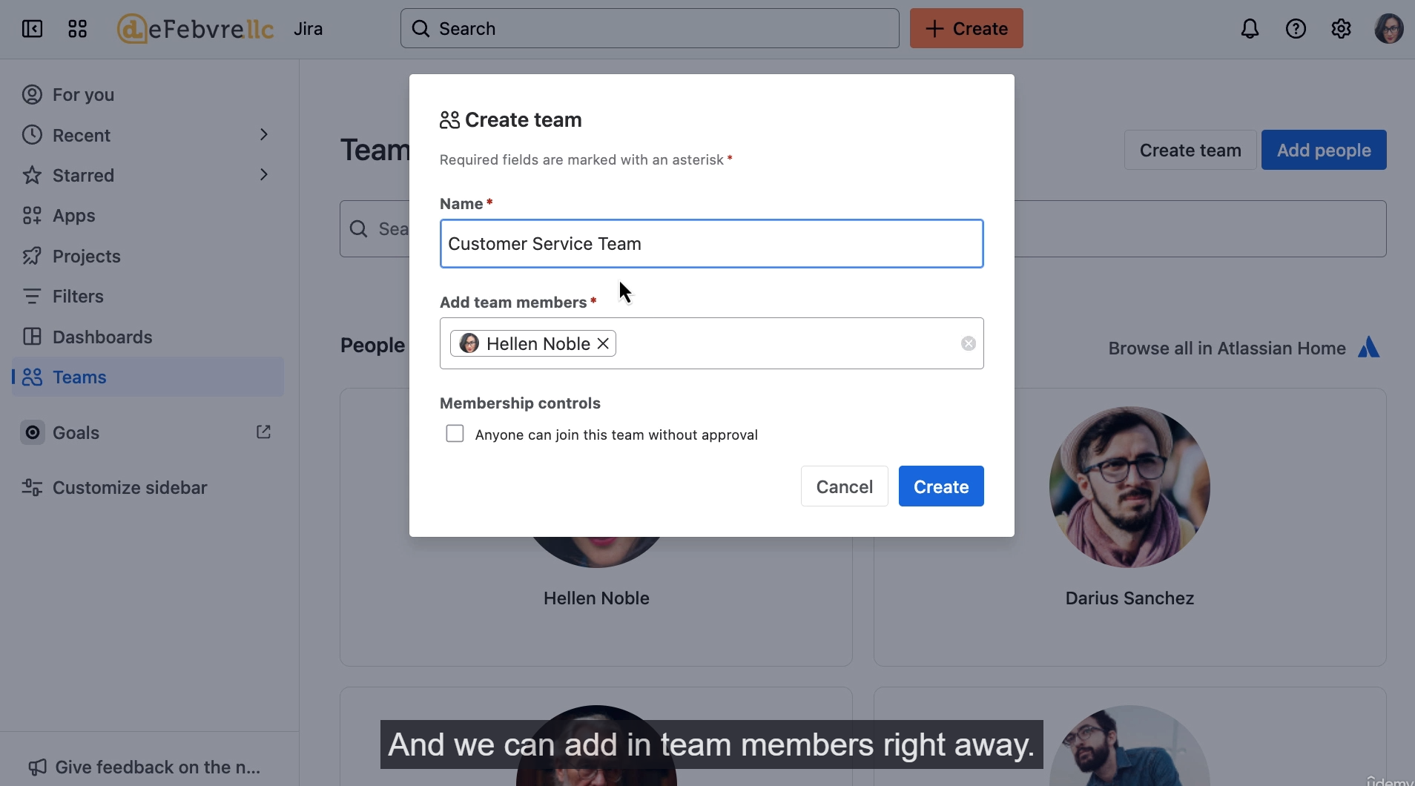

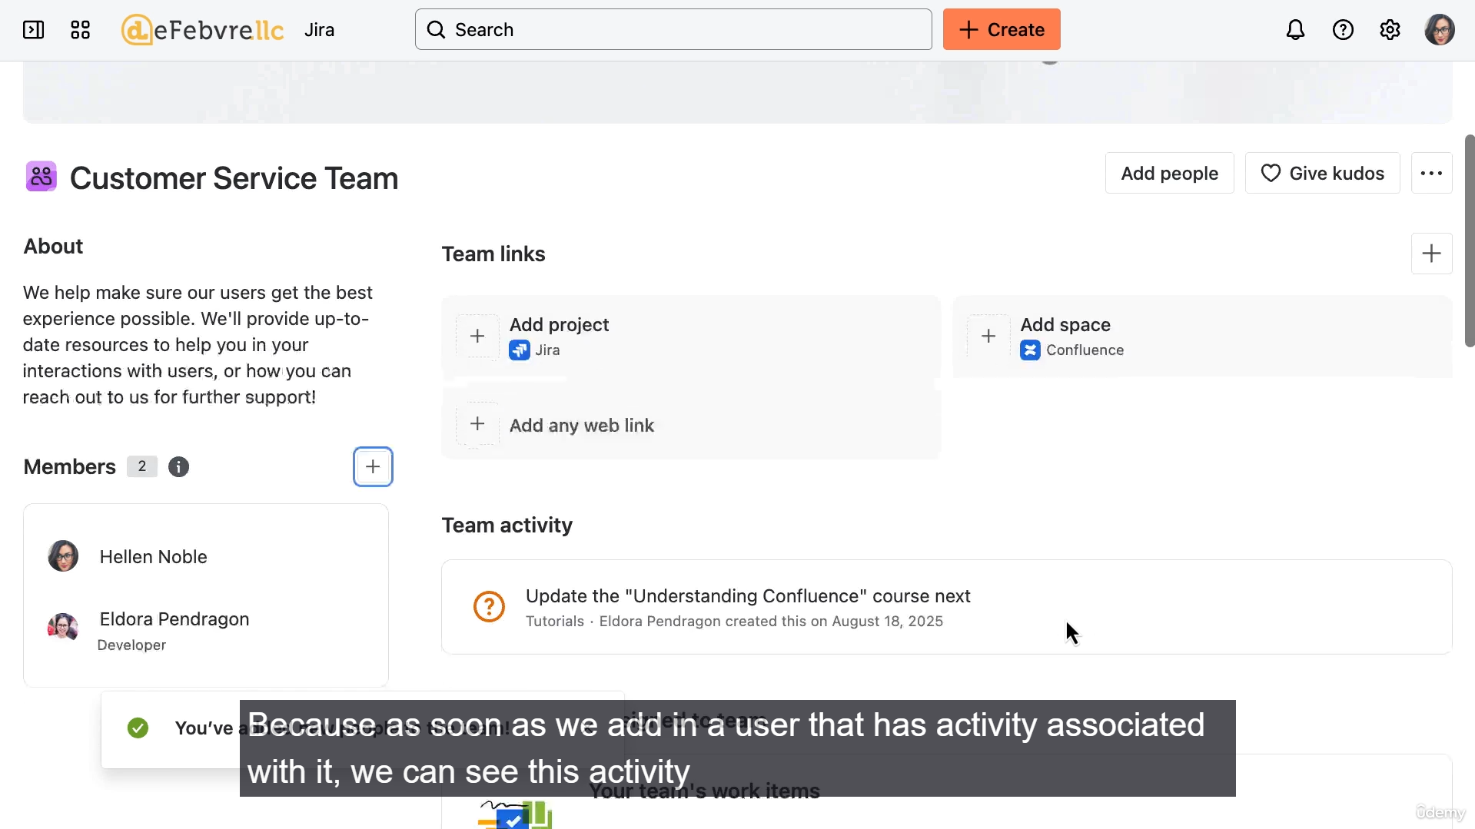

**What Jira Teams Are (and Are Not):**

* **Not Microsoft Teams:** Jira's teams feature is completely separate from Microsoft Teams, although you can connect Microsoft Teams to Jira for communication.
* **A Landing Page:** Jira teams are essentially a dedicated landing page for a collection of users (the team).
* **Not for Collaboration on Work:** The team page is *not* intended for the team members to collaborate on work; the rest of Jira is for that purpose.
* **Internal Facing:** Everything added to a team page is facing the rest of your Jira installation (your organization), not the public.
* **Intranet Landing Page Analogy:** The feature is described as being like an "intranet landing page" for the team, meaning the primary audience is other folks in the organization.

**Key Features and Customization:**

* **Creation:** Teams can be created from the left side menu in Jira using the "Create Team" button or the "+" button.
* **Team Members:** Members can be added during creation or later in the "about" section. When a user is added, their associated work activity and assigned work items start to show up on the team page.
* **Independence from Projects:** Teams work independently from Jira projects. A team doesn't have to have the exact same members as a project. This allows for flexibility in organizing projects based on overall project goals rather than just team structure.
* **Customization:**
  + **Header Image:** You can upload a customized header image.
  + **About Section:** Customize this section with information primarily directed at other people in the organization.
* **Displaying Related Work/Information (Landing Page Functionality):**
  + **Linked Projects/Apps:** You can link relevant Jira projects, Confluence pages (Atlassian's documentation wiki), or any other web links.
  + **Work Items:** Work items assigned to the team members automatically appear.
  + **Goals:** Goals the team is contributing to automatically appear (if your organization is using Jira goals).
  + **Atlassian Compass:** Components tracked in Atlassian Compass (for software components) will show up here.
  + **Relevant Help Links:** You can add links to resources like request forms or knowledge articles, which can be useful for the team itself or for the rest of the organization interacting with the team (e.g., a customer service team).
* **Kudos:** A feature built into the team pages to offer positivity and recognize team members. Kudos given appear on the team page and on the recipient's user profile.
* **Deletion:** A team can be deleted via the three-dot menu. **Warning:** Deleting a team permanently deletes everything added to it (like links), and it cannot be recovered by a Jira administrator.

**Future Use:**

* Creating a team unlocks back-end possibilities in Jira, such as quickly building an **agile board** for the team to get work done, which is the topic of the next video.

===================================================================================

1. **Creating a new scrum board and importing works:**

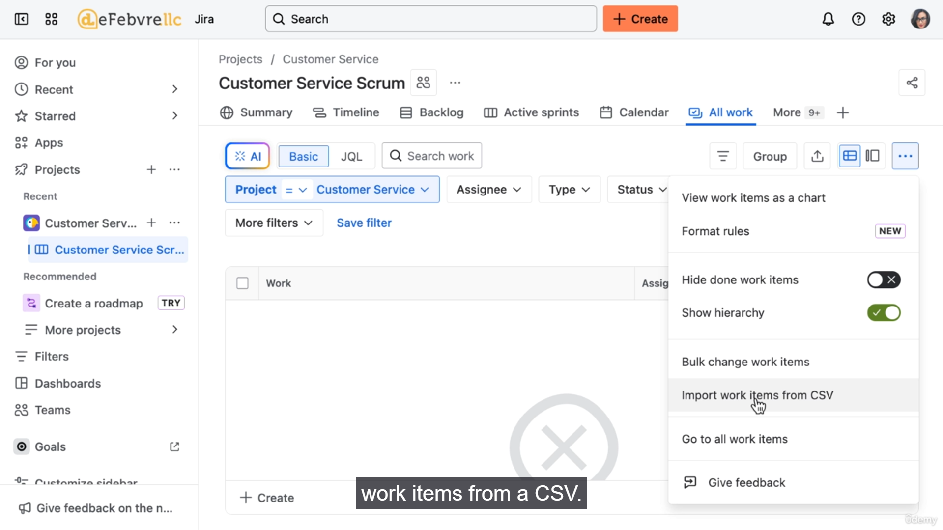

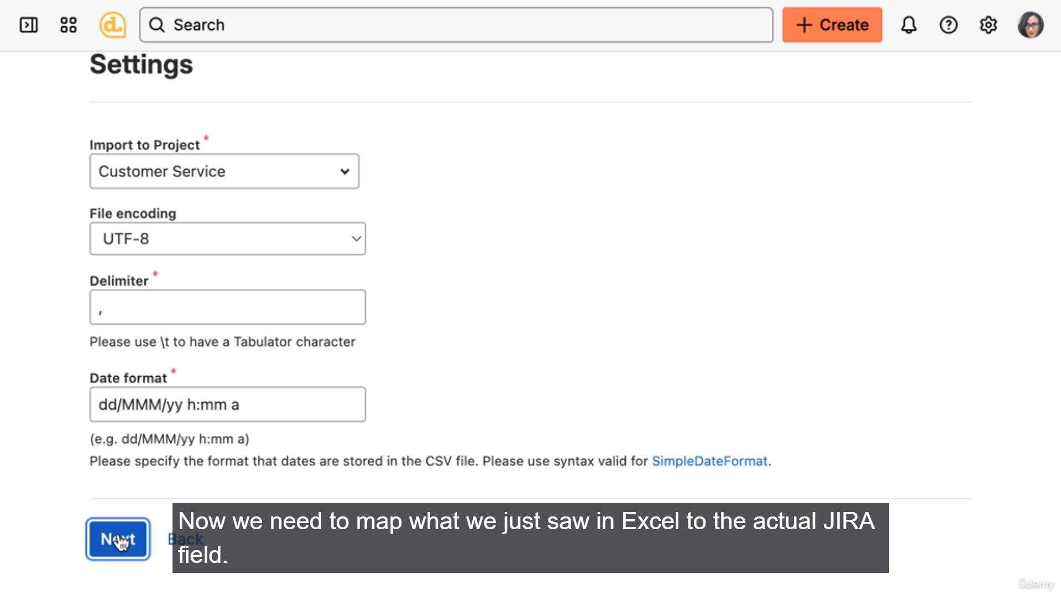

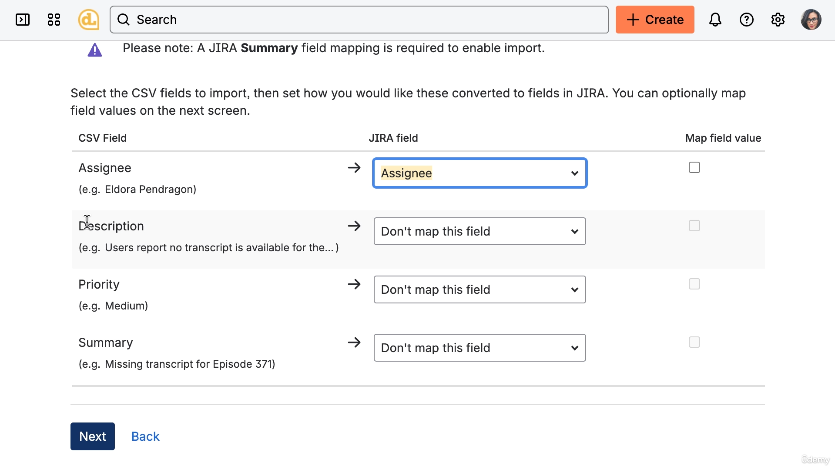

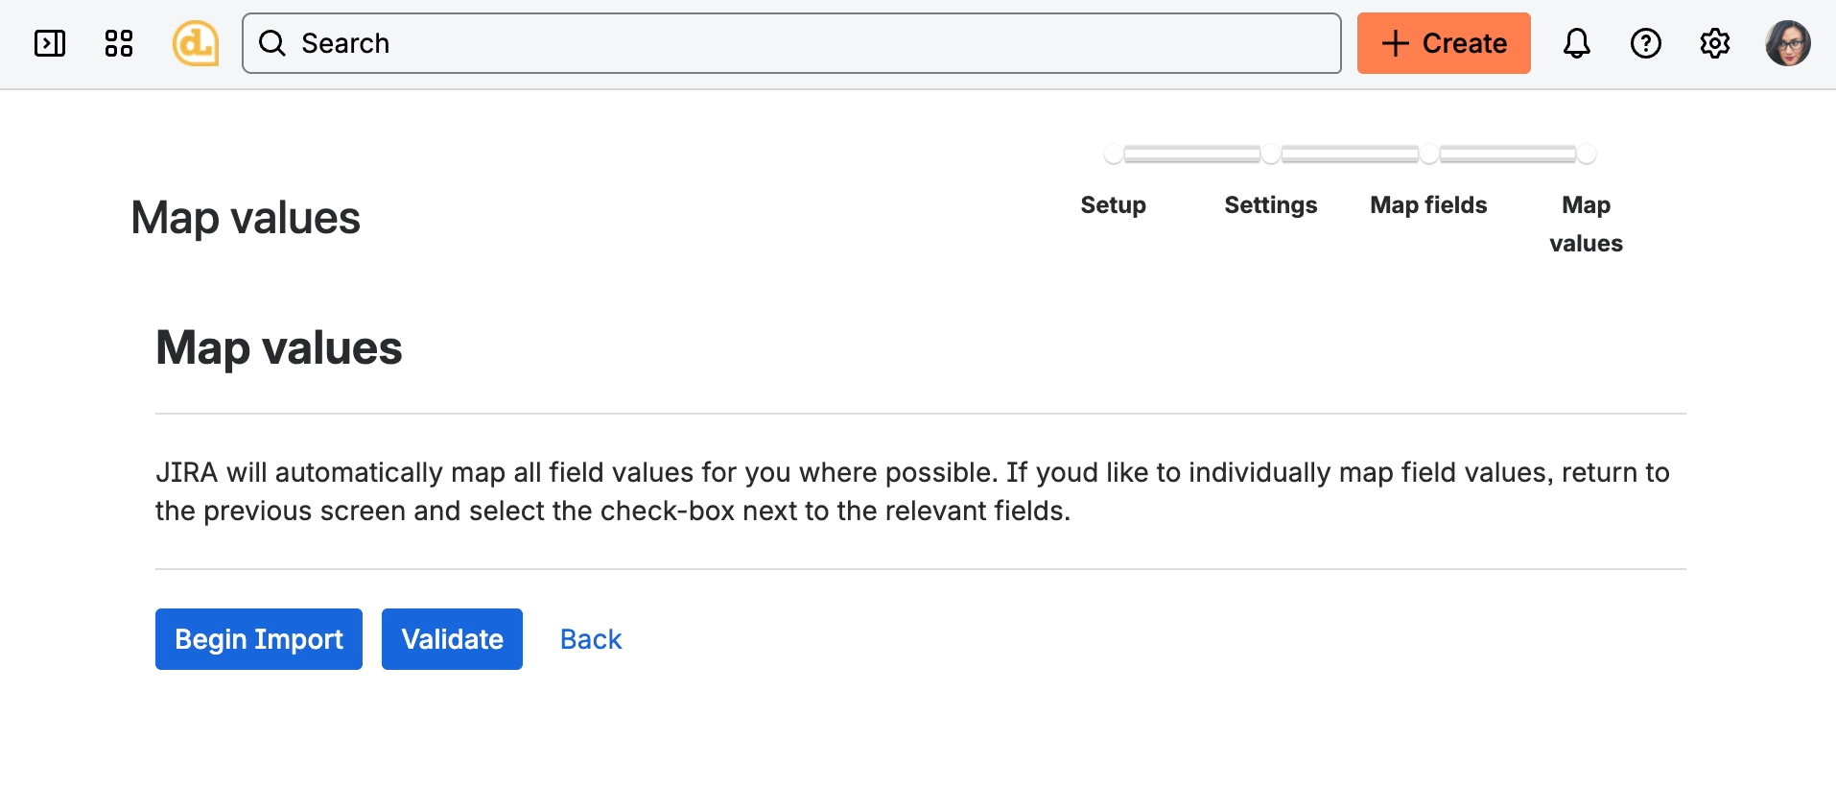

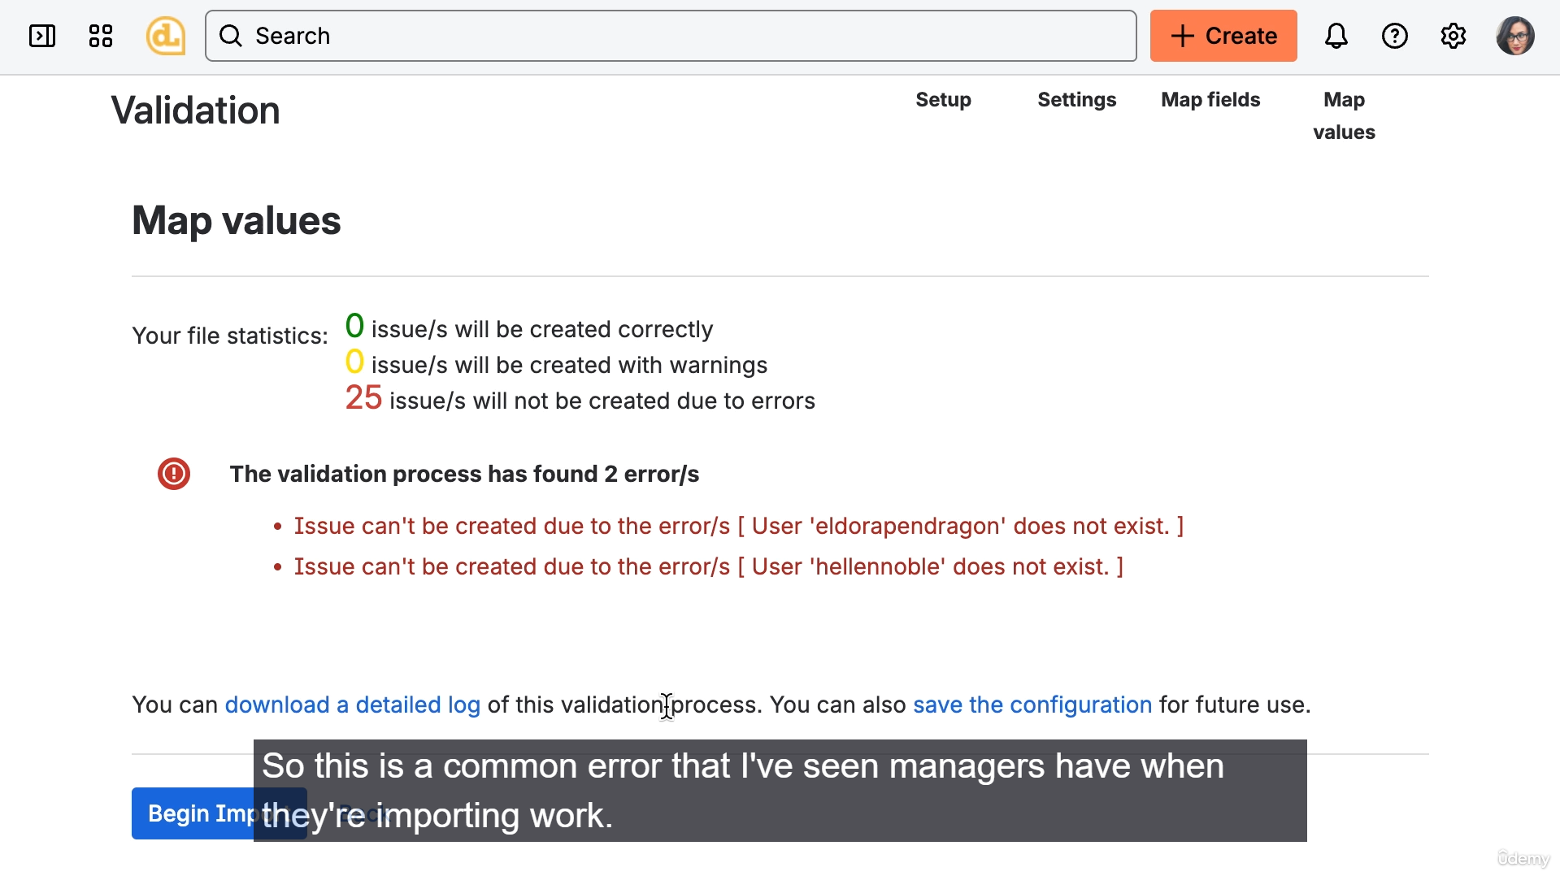

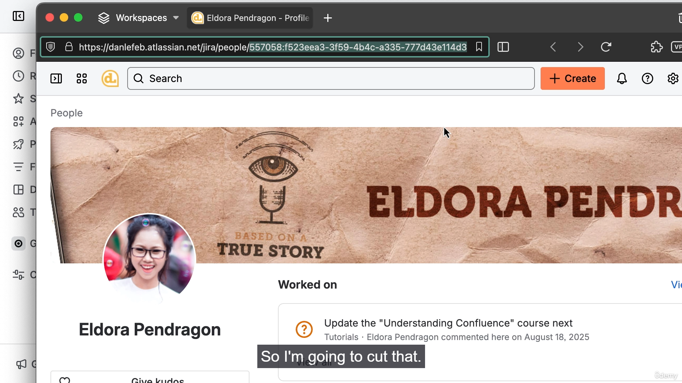

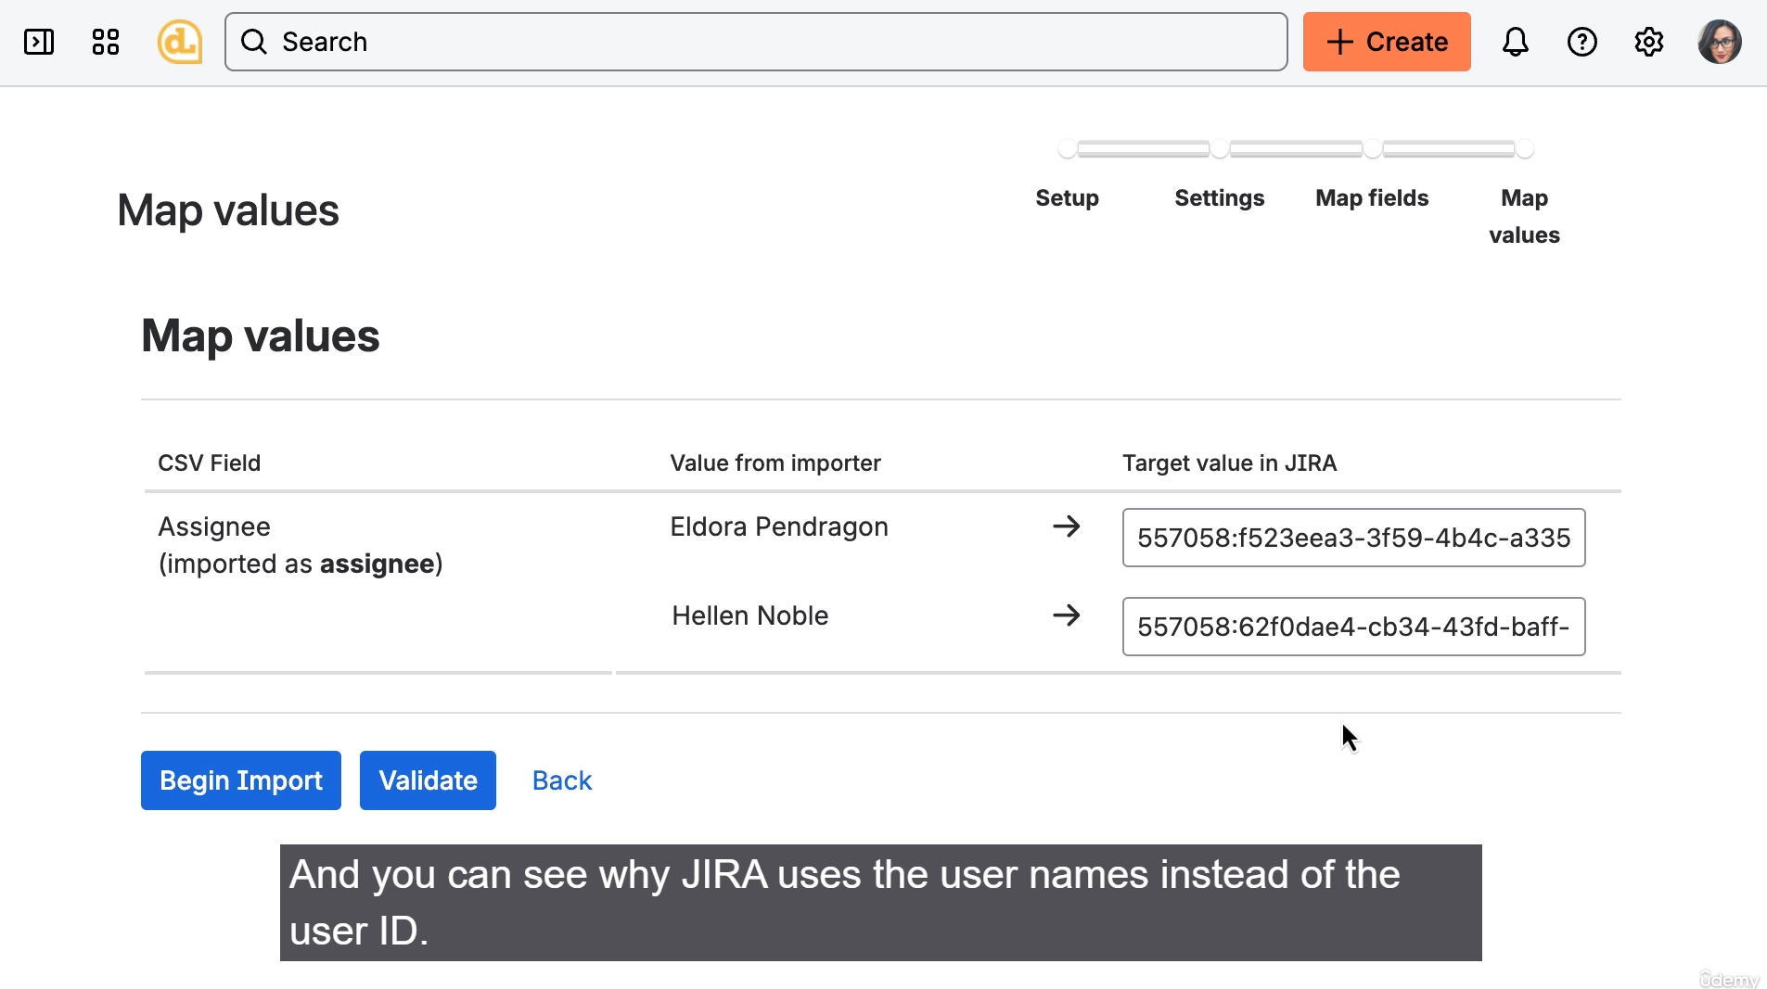

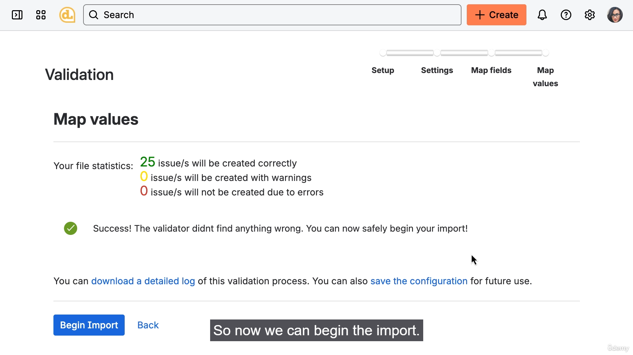

**1. Creating an Agile Board (Scrum)**

* **Default Board:** Jira automatically creates an Agile board when you create a new team-managed or company-managed project.
* **Multiple Boards:** A major benefit of company-managed projects is the ability to have **multiple boards** within the same project.
* **Creation Process:**
  1. Go to the desired **Project** (e.g., Customer Service Project).
  2. Click the **plus sign (+)** on the left menu.
  3. Select **Create new board**.
  4. Choose the **Scrum** type (Kanban will be covered later).
  5. **Name the board** (e.g., Customer Service Scrum).
  6. **Define Board Scope (Filter):** Jira uses a behind-the-scenes filter to determine which work items display on the board.
  7. **Select Team:** The board is scoped to include the work for the newly created **Customer Service Team**.

**2. Bulk Importing Work Items**

* Since the new board is empty, the video demonstrates a quick way to add work using a CSV import.
* **Steps for Import:**
  1. Go to **All work** in the project navigation.
  2. Click the **three dots (...)** menu.
  3. Select **Import work items from a CSV**.
  4. Follow the wizard:
     + **Select Project:** Choose the project where the items will live (e.g., Customer Service Project).
     + **CSV Mapping:** Map the columns from the CSV (e.g., Assignee, Description, Priority, Summary) to the corresponding Jira fields.
* **Handling the Assignee Error (The User ID Issue):**
  1. A common error when importing is that Jira is looking for the **User ID**, not the user's display name, for the Assignee field.
  2. **Solution:**
     1. In the mapping step, select **Map field value** for the Assignee field.
     2. Find the correct **User ID** for each user by viewing their user profile and copying the ID from the URL.
     3. Map the display name from the CSV (e.g., "Eldora") to the actual User ID in Jira.
  3. **Validation:** Run the validator to ensure the mappings are correct before importing.
  4. **Import:** Click "Begin Import" to create the new work items.

**3. Terminology Note**

* The video notes the ongoing transition in Jira terminology:
  + **"Issues"** are now called **"Work items."**
  + You may still see older terminology like **"Issue Key"** or the prompt to **"Check issues"** in the import tool, which are expected to be updated by Atlassian in the future.

**4. The Missing Work Items Problem**

* After a successful import, the work items are visible in the "All work" section but are **missing from the board's Backlog**.
* **Key Concept:** Jira boards **do not necessarily display all** work items that exist within a project.
* The next video will address this by explaining how to **control what work items show up on the Agile board**.

===================================================================================

* + 1. **Bulk editing and controlling work on scrum board:**

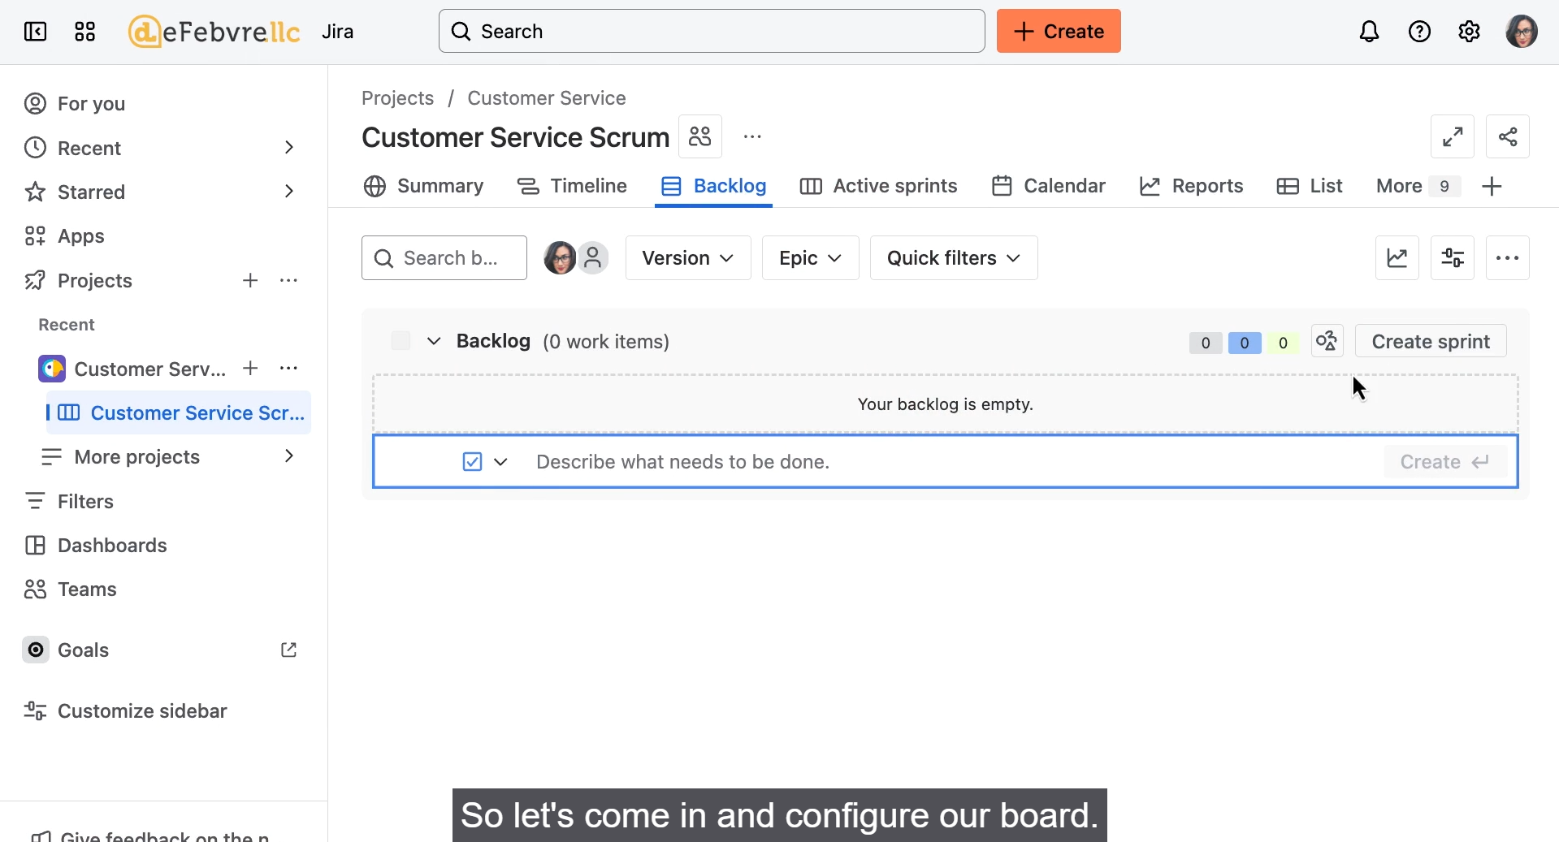

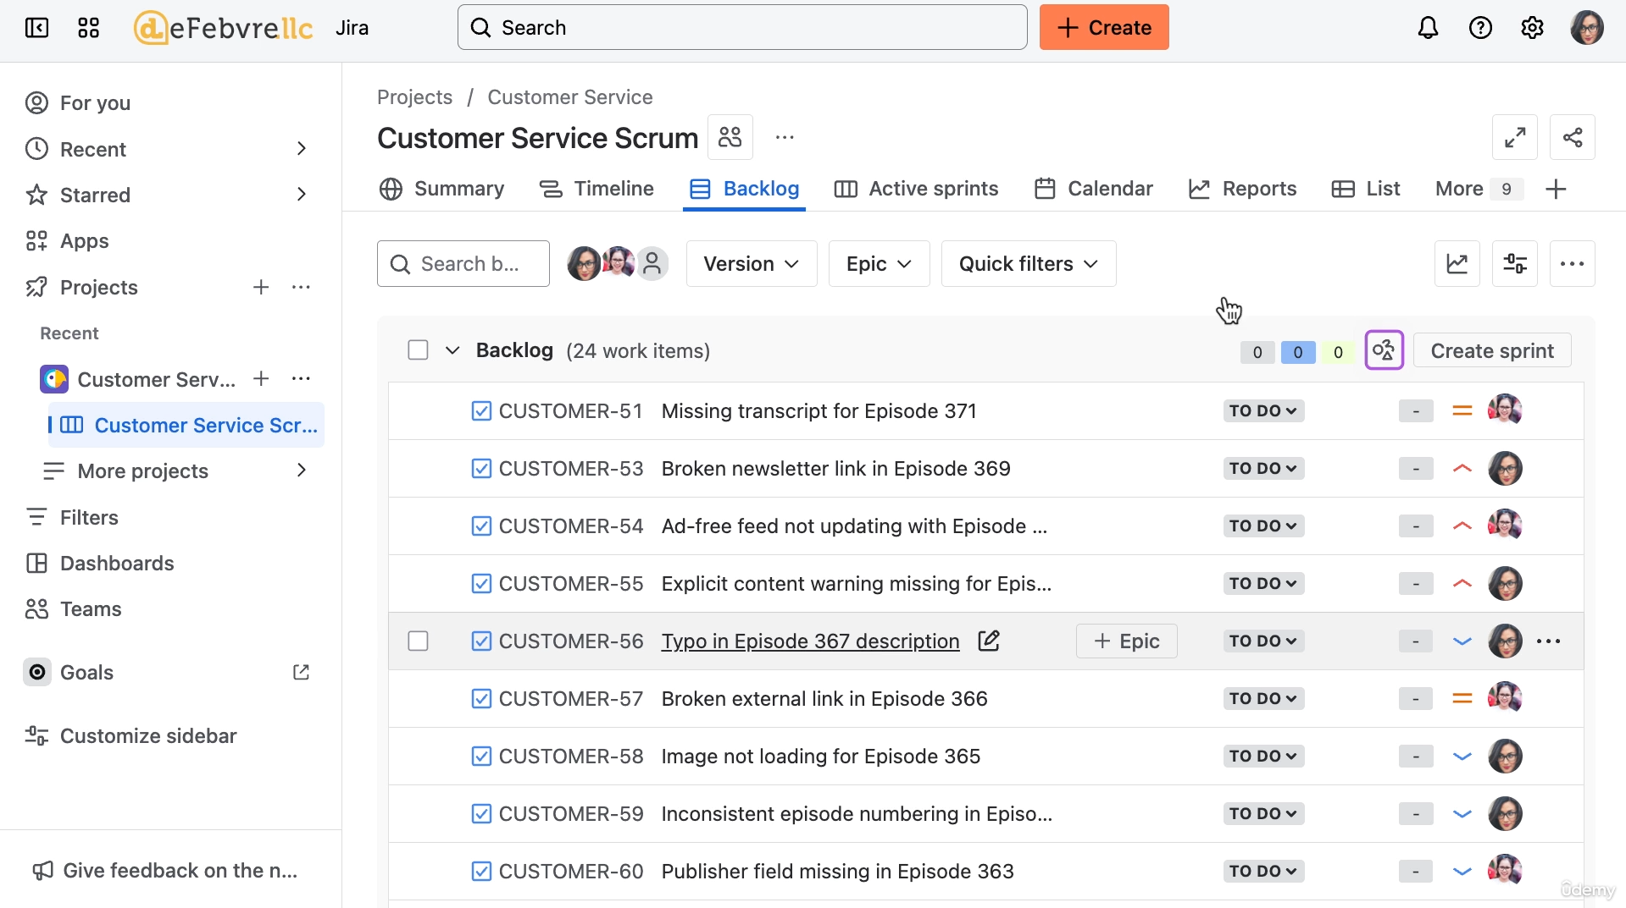

**1. Understanding the Board Filter**

* **The Problem:** The work items were visible in "All work" but not in the board's Backlog. This is because the board's display is driven by a **Board Filter**.
* **Filter Query:** The filter query (written in Jira Query Language or JQL) is essentially a saved search that determines which work items appear on the board.
* **Jira's Default Filter:** When the board was created, Jira automatically created a filter designed to search for work items assigned to the **Customer Service Team**. This was represented in JQL by a custom field ID and the team's internal ID (e.g., cf[ID] = "Team ID").
* **The Mismatch:**
  + When the work items were imported, they were assigned to individual **users** on the team (using the Assignee field).
  + They were **not** automatically associated with the **Team** custom field.
  + The board's filter was searching for the **Team** custom field, not the individual assignees, which resulted in "no results."

**2. Solving the Problem with Bulk Edit**

The solution is to perform a bulk edit on the imported work items to apply the "Customer Service Team" to the correct field.

* **Steps for Bulk Edit:**
  1. Go into the **Board Configuration** (or the filter's edit page) and temporarily **remove the team part** of the filter query. This allows the search to display all 25 imported work items.
  2. **Select All** of the work items.
  3. Click the **Edit fields** (or similar bulk action).
  4. Select the **Team field** (the custom field).
  5. Change the value to the **Customer Service Team**.
  6. **Confirm** the bulk update.

**3. Result**

* After the bulk action is complete, all 25 imported work items are now correctly associated with the **Customer Service Team** field.
* Returning to the Scrum board's Backlog, **all the work items are now displayed**, as they match the board's underlying filter query.

**4. Next Steps**

* With the work items now in the backlog, the team is almost ready for its first sprint.
* The next video will cover additional **board options** that should be configured to ensure Jira is properly set up for the team.

===================================================================================

* + 1. **Configuring our scrum board:**

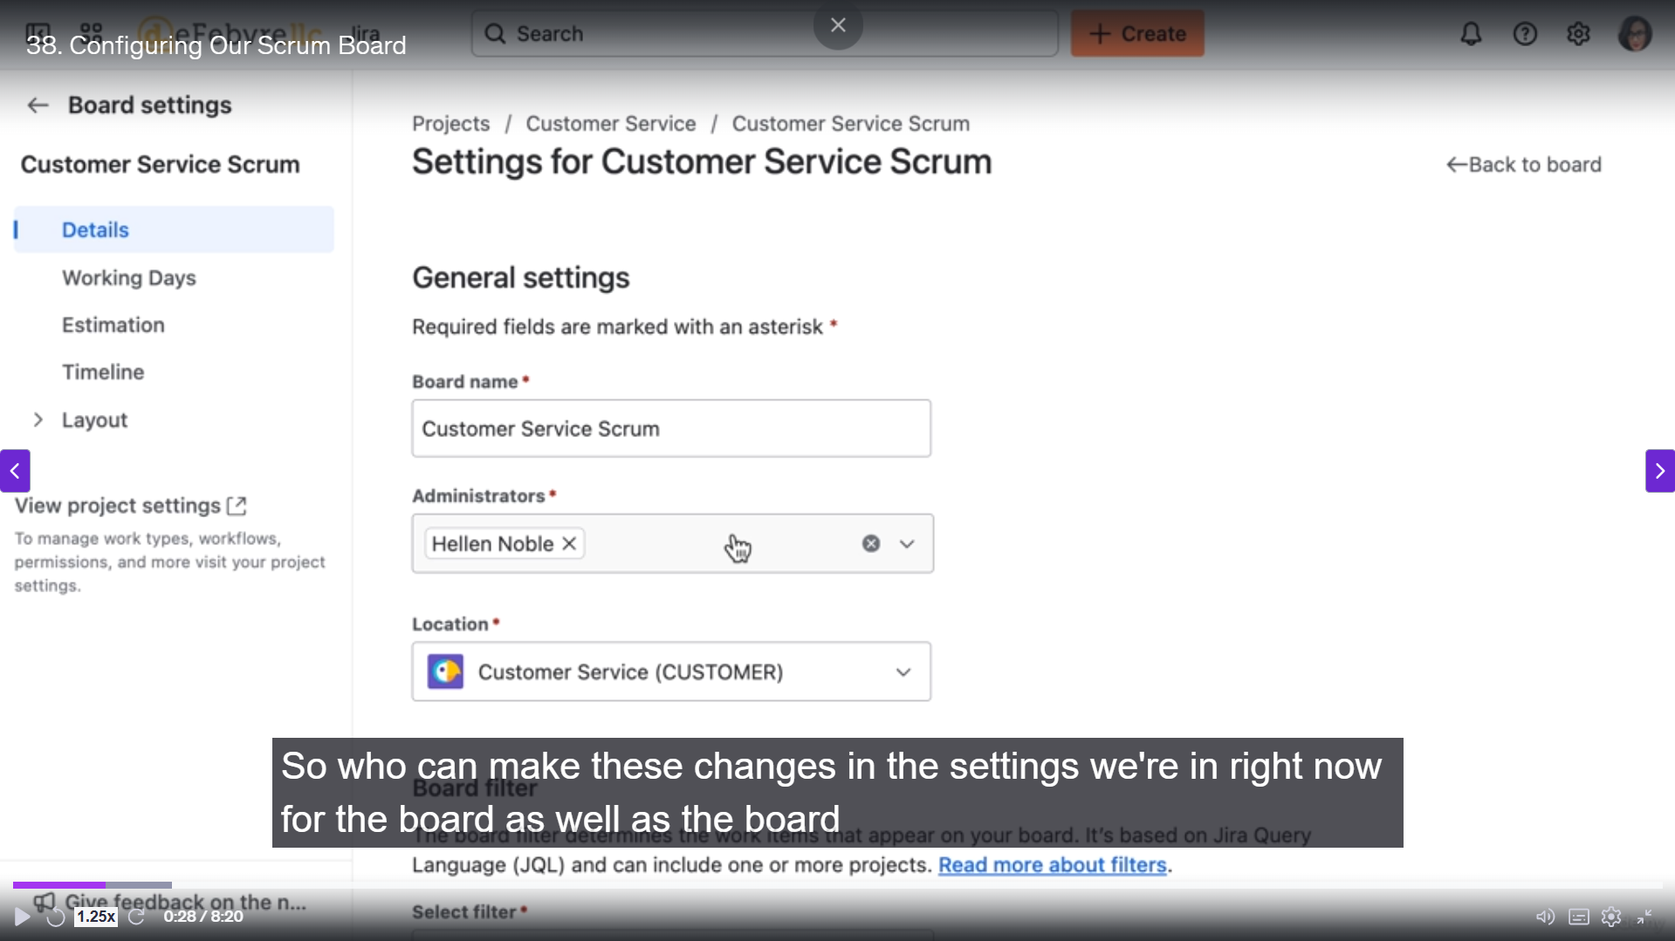

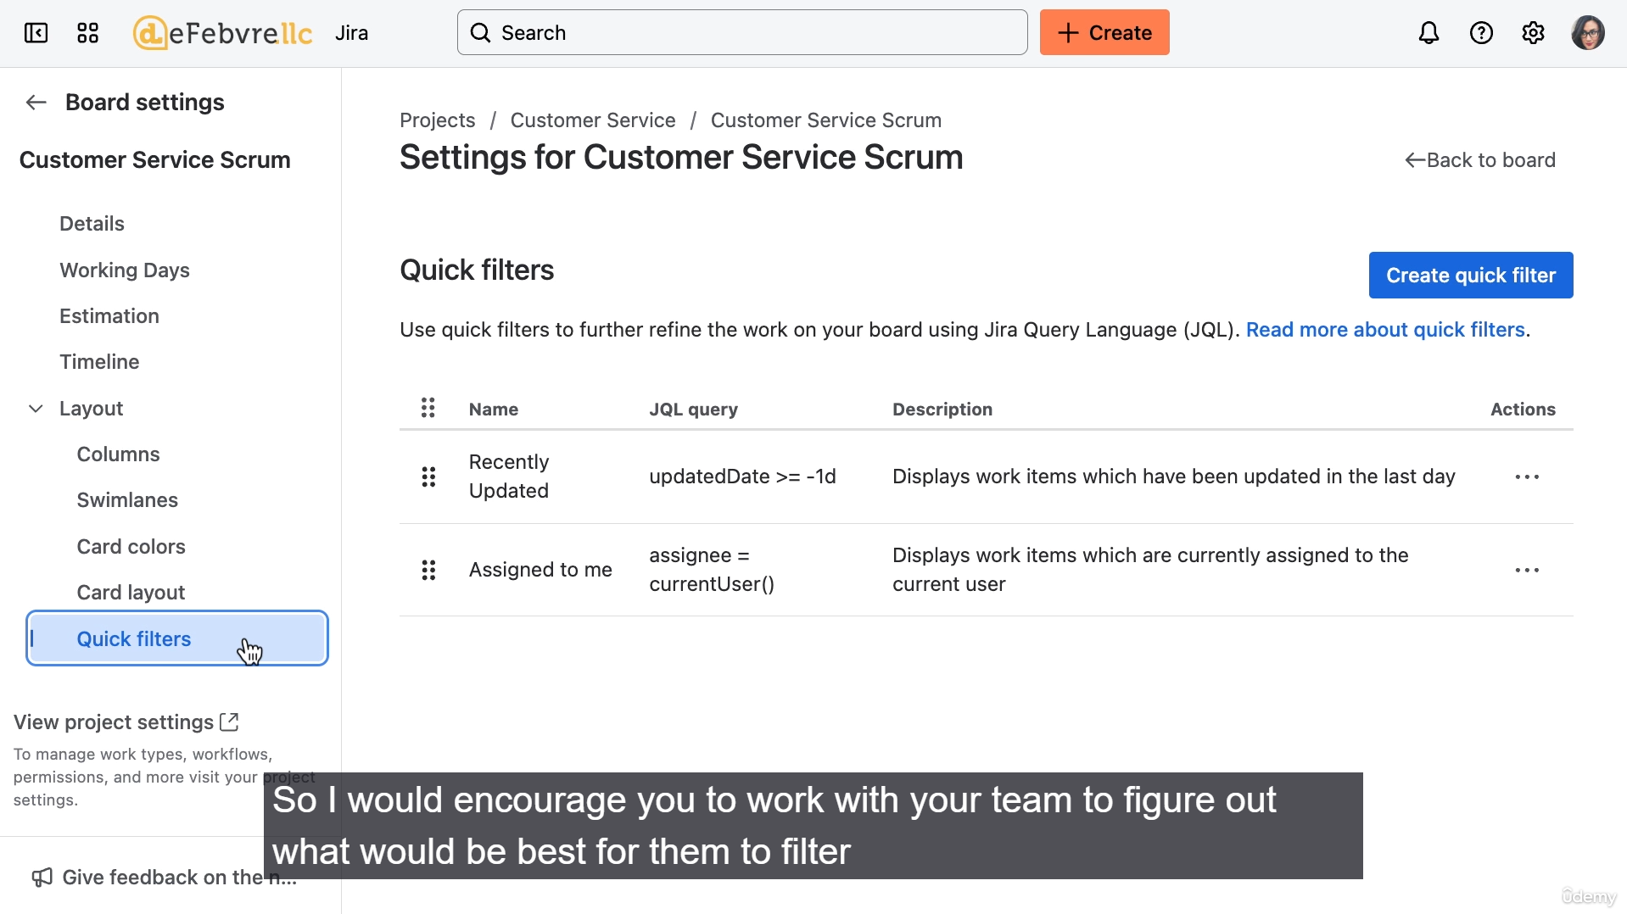

**1. General Board Settings**

* **Board Name & Administration:** Adjust the name, who has administrative permissions for the board settings, the project the board lives in, and the **Board Filter** (which controls which work items appear).

**2. Working Days and Estimation**

* **Working Days:** Allows you to confirm or change the days your team works (default is Monday–Friday) and the time zone. This is crucial for accurate board reports (e.g., burn-down charts).
* **Estimation:** A common area for customization.
  + **Default:** Story Points.
  + **Customization:** The example changes the estimation statistic to **Original Time Estimate** (tracking hours).
* **Time Tracking:** You can turn on the ability for the team to manually **log work** against each work item. (Note: This is manual logging, not an automatic timer.)
* **Timeline View:** Allows you to turn off the Timeline view if the team does not intend to use it, helping to clean up the board menu.

**3. Columns and Workflow**

* **Columns:** This is how you map the board columns to the underlying work statuses.
  + **Customization:** You can add new columns and associate one or more statuses with that column.
  + **Example:** A new **'In Review'** column was added, and a status (or statuses) would be associated with it, creating a distinct step on the board between 'To Do' and 'Done'.

**4. Visual Customization**

* **Swimlanes:** Allows you to set up the default **horizontal grouping** of work items (e.g., by assignee, priority, etc.) for everyone who uses the board. (In contrast to individual user display settings).
* **Card Colors:** Provides a quick visual way to differentiate work items.
  + **Customization:** You can change the card coloring based on criteria like **Priority**.
  + **Example:** Configuring Low Priority to display as light green and High Priority as red.
* **Card Layout:** Configures which fields are visible on the card preview when the work item is displayed on the active sprint board. (Not fully demonstrated since no sprint was active).

**5. Quick Filters**

* **Function:** Quick filters are convenient, saved searches located directly on the board (both Backlog and Active Sprint) that allow users to rapidly filter the work items.
* **Creation Process:**
  1. Go to the Quick Filters section in configuration.
  2. Define a **Filter Name** and a **Jira Query Language (JQL)** query.
* **Example:** Creating a filter named **"Over Three Hours"** with the JQL: Original Time Estimate > 3.
* **Demonstration:** The video shows how to quickly add time estimates to work items (via the Edit fields modal) and then uses the newly created quick filter to instantly display the larger work items in the backlog.

===================================================================================

* + 1. **Our first sprint on scrum board:**

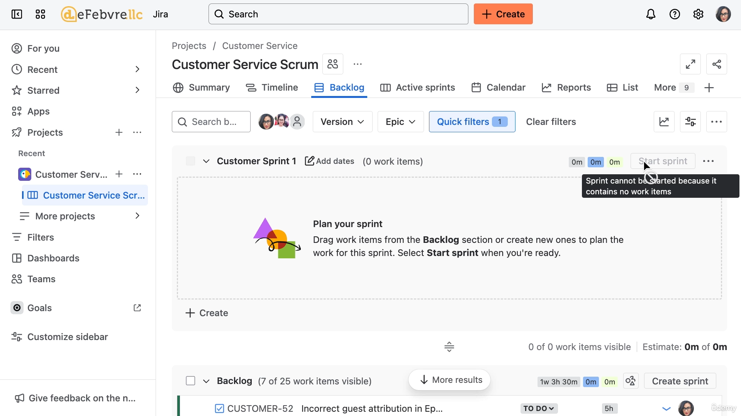

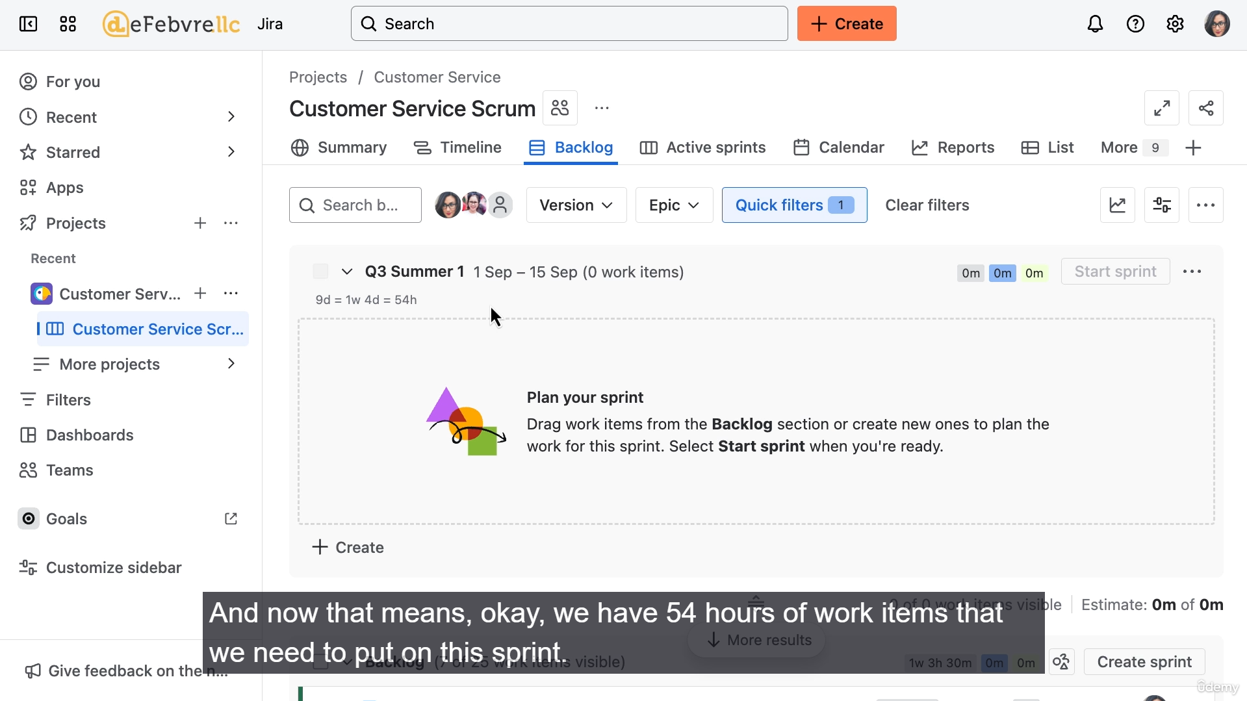

**1. Pre-Meeting Preparation (Manager's Role)**

The manager should set up the sprint in Jira *before* the team meeting to save time.

* **Create the Sprint:** In the Backlog view of the board, click "Create sprint."
* **Rename and Date:** Give the sprint a meaningful name (e.g., "Q3 Summer Sprint One") and set the **Start Date** and **End Date** to define the duration (e.g., two weeks).
* **Set the Sprint Goal/Description:**
  + This is a description field, but a helpful tip is to include the **total estimated working hours** for the sprint.
  + **Example Calculation:** (6 working hours/day) * (10 days in 2 weeks) - (6 hours for 1 holiday day) = **54 hours** total work.
  + This hours total provides a quick reference for sizing the sprint's workload.

**2. Sprint Planning Meeting Process**

The meeting's goal is to commit to the work that will fill the sprint's capacity (e.g., 54 hours per team member).

* **Retrospective (for future sprints):** A typical sprint meeting starts with a retrospective on the previous sprint, but this is skipped for the first sprint.
* **Time-Saving Tip:** Encourage team members to have their proposed work items already created in Jira and estimated (in hours or story points) *before* the meeting.
* **Review and Commitment (Per User):**
  1. **Filter by User:** Use the quick filter to show only the work items assigned to the current team member (e.g., Eldora).
  2. **Add Work to Sprint:** Drag and drop work items from the **Backlog** into the newly created **Sprint** block.
  3. **Track Estimates:** As items are added, Jira displays a running total of the estimated work (e.g., "2 days, 1 hour") at the bottom of the sprint block. This is compared against the calculated sprint capacity (e.g., 9 days or 54 hours).
  4. **Discussion:**
     + Review priorities and determine if these are the right items for the sprint.
     + Discuss and adjust time estimates if necessary (e.g., an hour estimate is changed to 30 minutes, or a day and three hours).
  5. **Rebalancing Work:** If one team member has too much work and another doesn't have enough, use the sprint meeting as a chance to discuss reassigning and moving work items between team members and into the sprint.

**3. Quick Navigation Tips**

* **Drag and Drop:** The fastest way to add or remove work items from a sprint.
* **Keyboard Shortcuts for Organization:**
  + **S and T:** Send a selected work item to the **Top** of the backlog.
  + **S and B:** Send a selected work item to the **Bottom** of the backlog.
* **Multi-Selection:** Use **Ctrl/Cmd-Click** or **Shift-Click** to select multiple work items simultaneously for dragging or other bulk actions.

**4. Starting the Sprint**

* Once the team agrees on all the work to be included, the manager officially **Starts the Sprint**.
* This moves the sprint's work items from the **Backlog** to the **Active Sprint** view, and the actual sprint clock begins counting down.

**5. Post-Meeting Reflection**

The video advises the manager to conduct a personal retrospective after the first planning meeting to improve future sprints: What went well? What didn't go well? How can the next sprint meeting be more effective?

The next video will cover the day-to-day workflow and how to complete the sprint once the work is done.

===================================================================================

* + 1. **Workflow of a sprint in daily stand-up:**

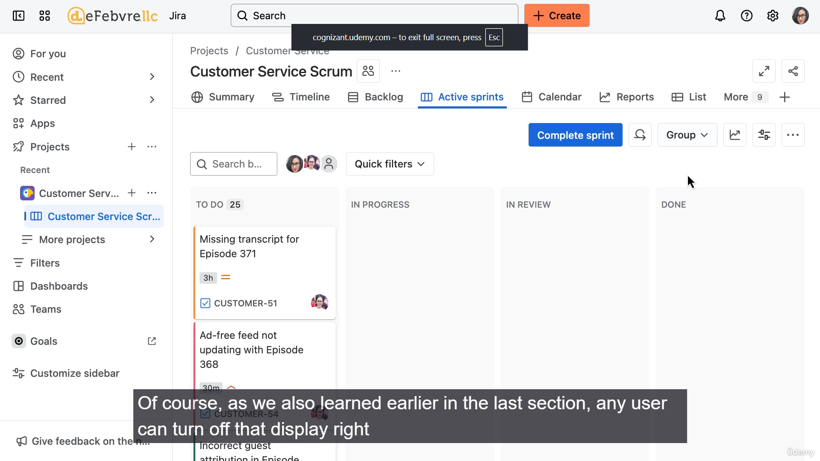

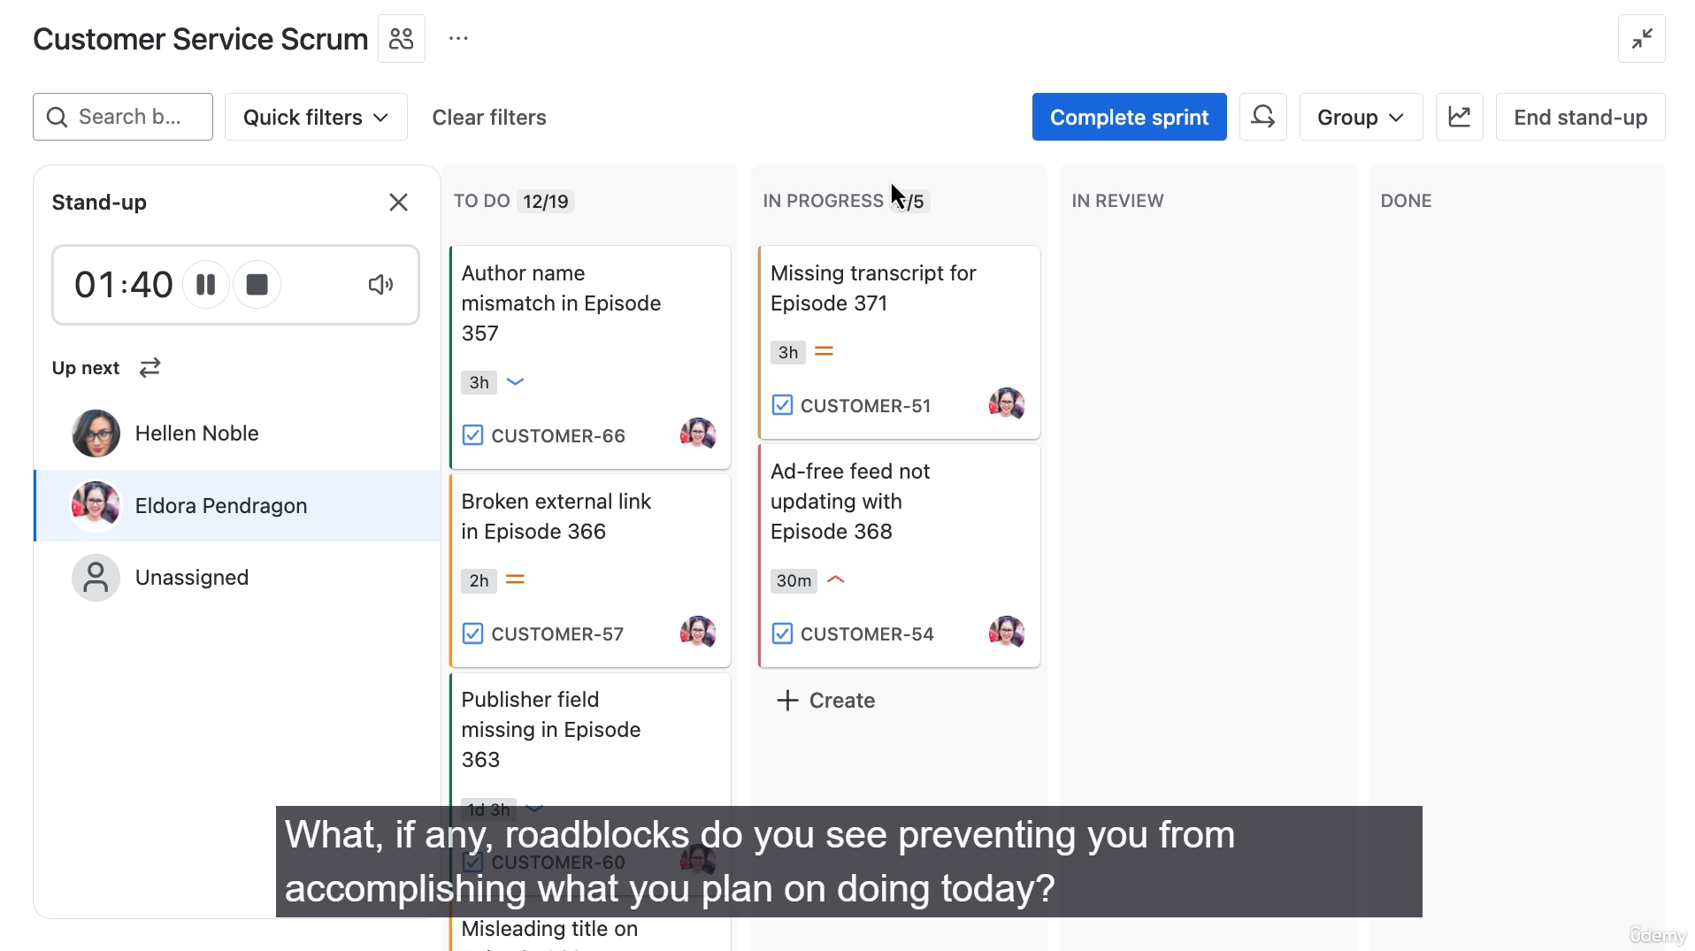

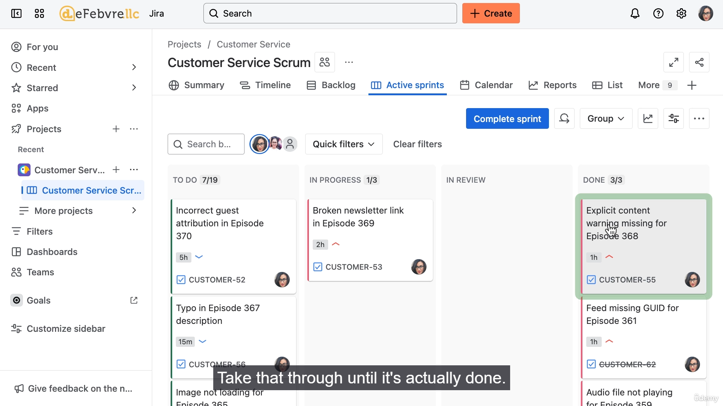

**1. Day-to-Day Workflow**

* **Active Sprint Board:** The team works off the **Active Sprint** board.
* **Swimlanes (Grouping):** The work is grouped according to the configured swimlanes (e.g., by Stories or Assignees). Users can adjust their personal display settings if they prefer a different grouping.
* **Individual Ownership:** Each team member is responsible for deciding which of their committed work items to tackle each day. High-priority items are generally tackled first.
* **Left-to-Right Flow:** Work items are moved across the board, one column at a time, until they reach the "Done" status.

**2. The Daily Standup**

The daily standup is a core Agile concept—a short, fast meeting (meant to be completed while standing) held each morning.

* **Purpose:** To keep the team synchronized and quickly identify roadblocks.
* **Three Questions:** Each team member answers:
  1. **What did you do yesterday?**
  2. **What will you do today?**
  3. **What, if any, blockers might prevent that from happening?**
* **Jira Standup Interface:**
  1. Access via the **three dots (...)** menu on the Active Sprint board.
  2. Jira provides a **random order** for team members (which can be shuffled).
  3. It includes a **two-minute timer** per person to keep the meeting brief and focused.
  4. During the standup, the team can discuss and **drag work items** to the "In Progress" column to commit to the day's work.
  5. The manager uses the third question to identify and resolve roadblocks for the team.

**3. Handling Work and Roadblocks**

* **Completing Work:** When a work item is dragged into the "Done" column, Jira automatically sets the work item's status as **"Resolved"** (indicated by the item being crossed out). Dragging it back out removes the resolution.
* **Linked Issues (Dependencies):**
  + A work item can be linked to another item using the **"is blocked by"** link type.
  + This visually indicates a dependency, even if the blocking item belongs to a different project or team.
  + The manager can use this insight to communicate with other teams and help unblock their team member. The link is removed once the dependency is resolved.
* **Flags (Temporary Attention):**
  + Use the **flag** feature to draw attention to a work item (e.g., a question, a minor issue).
  + Flagged items are visible on the board and are natural discussion points during the next standup. The flag is removed once the issue is addressed.
* **Taking on New Work:** If a team member finishes all their planned work for the day, they can pull in an additional low-priority item from the sprint queue.

**4. Conclusion**

The daily standup and the board workflow create an efficient, open cycle where everyone knows what is happening and can support each other to complete all work items in the sprint. The next video will cover how to formally complete the current sprint and start the cycle over.

===================================================================================

* + 1. **Complete a sprint and starting a new one:**

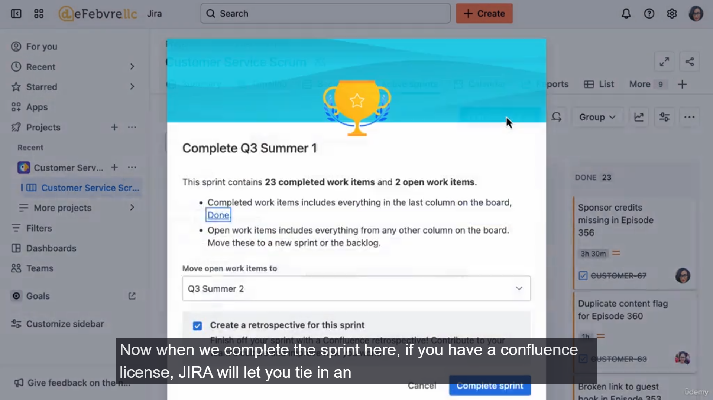

The video guides through the final steps of completing a Scrum sprint and starting the next one, demonstrating how the sprint cycle becomes a continuous loop of work, reflection, and planning.

Here is a summary of the key steps and concepts:

**1. Preparation for the Next Sprint**

Before the team meeting, the manager should create the next sprint container in the Backlog.

* **Create Next Sprint:** Click "Create sprint" in the backlog.
* **Name and Duration:** Name it (e.g., "Q3 Summer Sprint Two") and set the two-week duration.
* **Update Sprint Goal:** Calculate and add the updated estimated working hours for the team. Since there is no holiday in this example, the capacity is **10 days or 60 hours** per person.

**2. Sprint Retrospective**

The retrospective is a crucial part of the cycle, serving as an opportunity for the team to reflect and improve. It takes place while viewing the completed sprint (Active Sprint view).

* **Goal:** Iterative improvement for the next sprint.
* **Confluence Integration (Optional):** Jira can link to a dedicated retrospective page template in Confluence (a separate Atlassian product), but the meeting can be done without it.
* **Three Questions (Answered by each team member):**
  1. **What went well?** (Celebrate wins and identify successful processes.)
  2. **What didn't go well?** (Review work items that weren't completed and discuss the reasons—e.g., unexpected illness, technical issues, inaccurate estimates.)
  3. **What can we do better next time?** (Focus on 1-2 practical improvements, such as techniques for more accurate time estimation.)

**3. Completing the Sprint in Jira**

* **Completing the Sprint:** When the manager clicks **"Complete sprint"** on the Active Sprint board, Jira automatically handles any remaining open work items.
* **Automatic Movement:** Any open work items (those not moved to "Done") are automatically moved to the **next created sprint** in the backlog.
* **Result:** The previous sprint is closed, and the two incomplete items are now prepopulating the new "Q3 Summer Two" sprint.

**4. Planning the Next Sprint**

The process for planning the new sprint is exactly the same as the first one.

* **Sprint Planning:** The team filters by user (e.g., Eldora, Helen) and drags work from the backlog into the new sprint container.
* **Capacity Check:** Use the hours total in the sprint goal (e.g., 60 hours) to ensure each team member is assigned the correct amount of work.
* **Start the Sprint:** Once the team is happy and committed to the work, the manager clicks **"Start this sprint."**

This final step closes the loop, and the team moves to the **Active Sprint** board to begin the new cycle of work, daily standups, and progress. The next video will cover how to handle interruptions and new, high-priority work that arises mid-sprint.

===================================================================================

* + 1. **Adding work in sprint middle:**

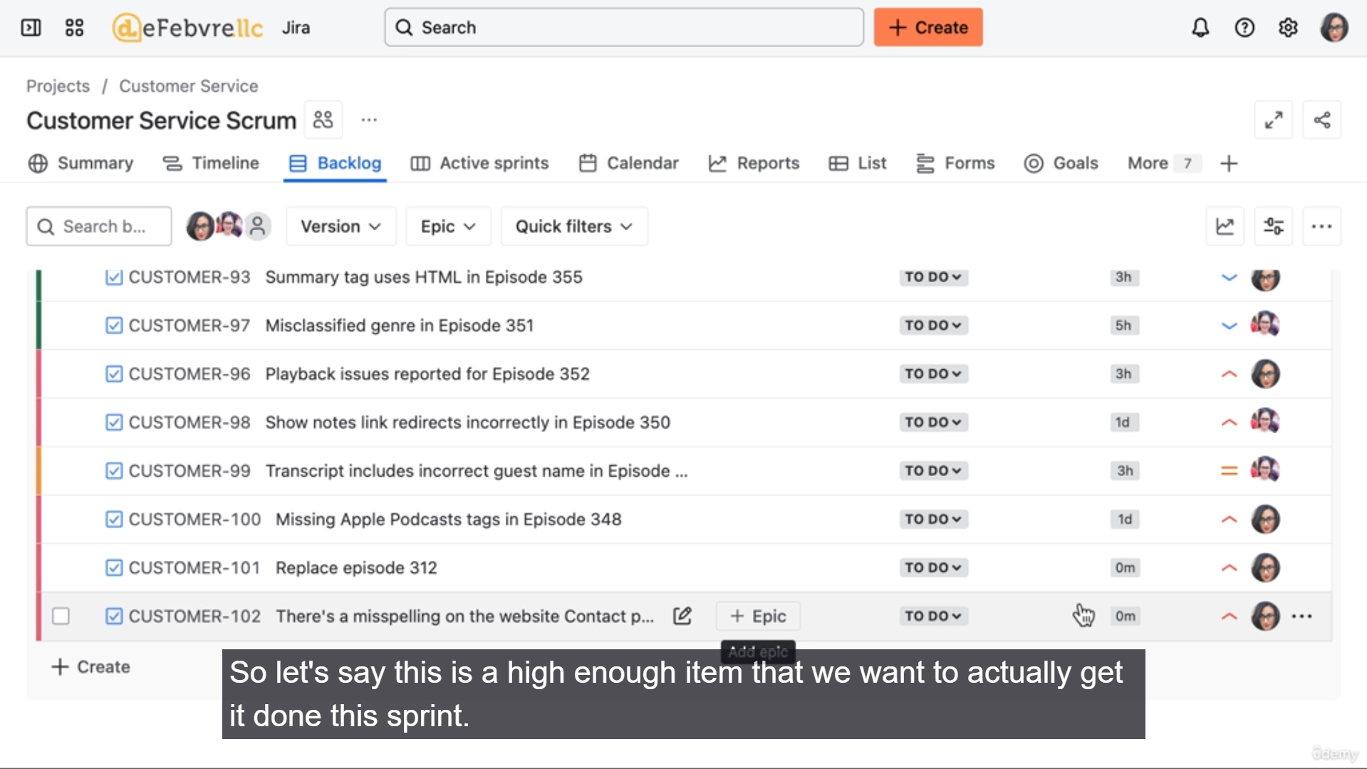

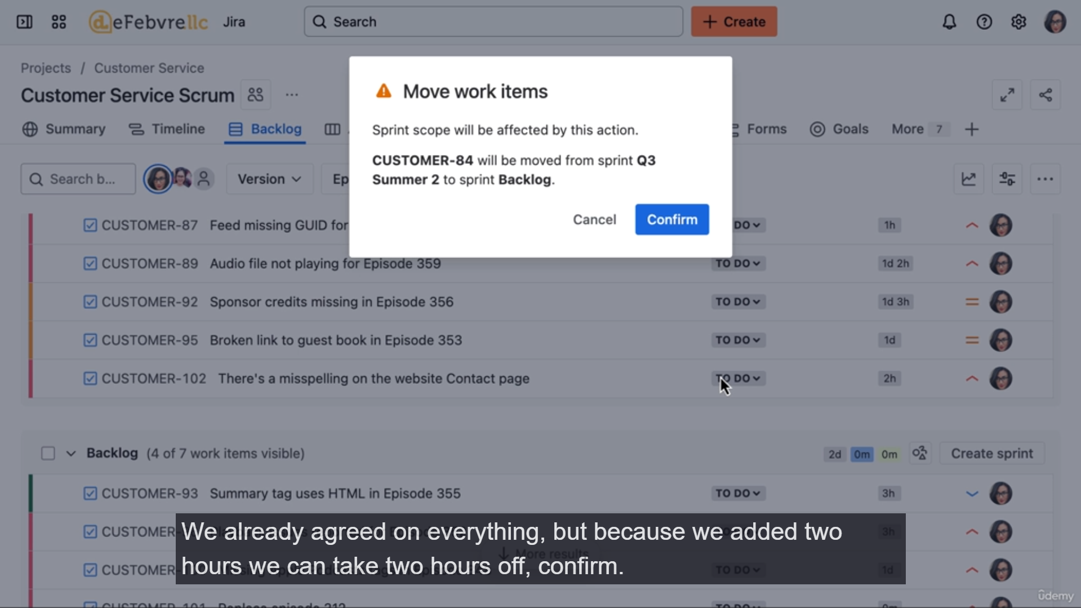

**1. The Scrum Principle Against Mid-Sprint Changes**

* **Fixed Scope:** The entire point of a Scrum sprint is that the time (and capacity) has been fully allocated during the planning meeting. **New work cannot be added without removing existing work.**
* **Default Behavior:** When a new work item is created in Jira, by default, it is added to the **Backlog**, not the active sprint. It waits until the next sprint planning meeting for consideration.
* **The Key Question:** When a request for mid-sprint work comes in (especially from outside the team), the team member should be encouraged to ask: **"Can I add this to my backlog, or is this high enough priority to replace other work on the sprint?"** This forces the requester to prioritize their work against the work the team has already committed to.

**2. Process for Adding High-Priority Mid-Sprint Work**

If the new work is genuinely high-priority and must be done during the current sprint, the following steps are required to maintain the sprint's scope:

**Step 1: Add the New Work**

1. **Estimate:** Ensure the new work item has a **time estimate** (e.g., 2 hours).
2. **Add to Sprint (Option 1 - Drag and Drop):** Drag the new item from the Backlog into the Active Sprint block.
   * **Jira Pop-up:** Jira will display a warning pop-up that says, "Hey, you're changing the scope of this sprint. Are you sure you want to do this?"
   * **Confirm:** Click **Confirm** to add the work item.

**Step 2: Remove Equivalent Work**

Since the sprint capacity is fixed, an equivalent amount of work must be removed to compensate for the added time (e.g., remove 2 hours of existing work).

1. **Remove from Sprint (Option 1 - Drag and Drop):** Drag an item of similar size from the Active Sprint block back into the **Backlog**.
   * **Jira Pop-up:** This action will also trigger the "changing the scope" warning pop-up, reminding you of the change.
2. **Remove from Sprint (Option 2 - Three Dots):** Click the **three dots (...)** on a work item card and select **"Remove from sprint."**
   * *Note: This option removes the item without the confirmation pop-up, which the manager may prefer or dislike, depending on their workflow preference.*

**3. Reviewing Scope Changes**

* **Reporting:** All work moved on or off a sprint mid-cycle is recorded in Jira's reports (e.g., the Sprint Report).
* **Retrospective Discussion:** If the reports show a lot of work being moved mid-sprint, this should be a major topic in the next **sprint retrospective**.
* **Scrum Rule:** Changing the scope of a sprint should be the **exception, not the rule**, in a true Scrum Agile workflow.

The video concludes by introducing the **Kanban** workflow as an alternative for teams that do not work well with fixed-scope sprints, setting up the next set of videos.

===================================================================================

* + 1. **Creating a kanban board:**

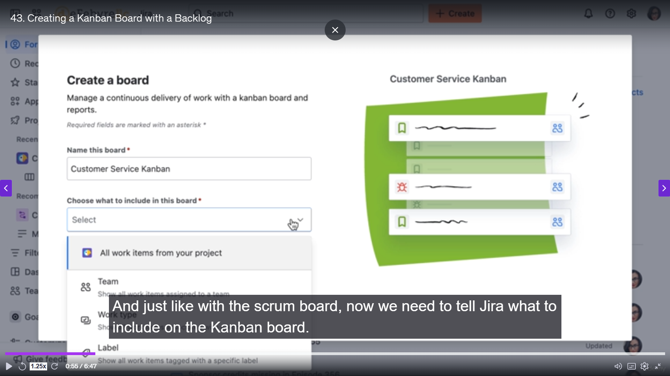

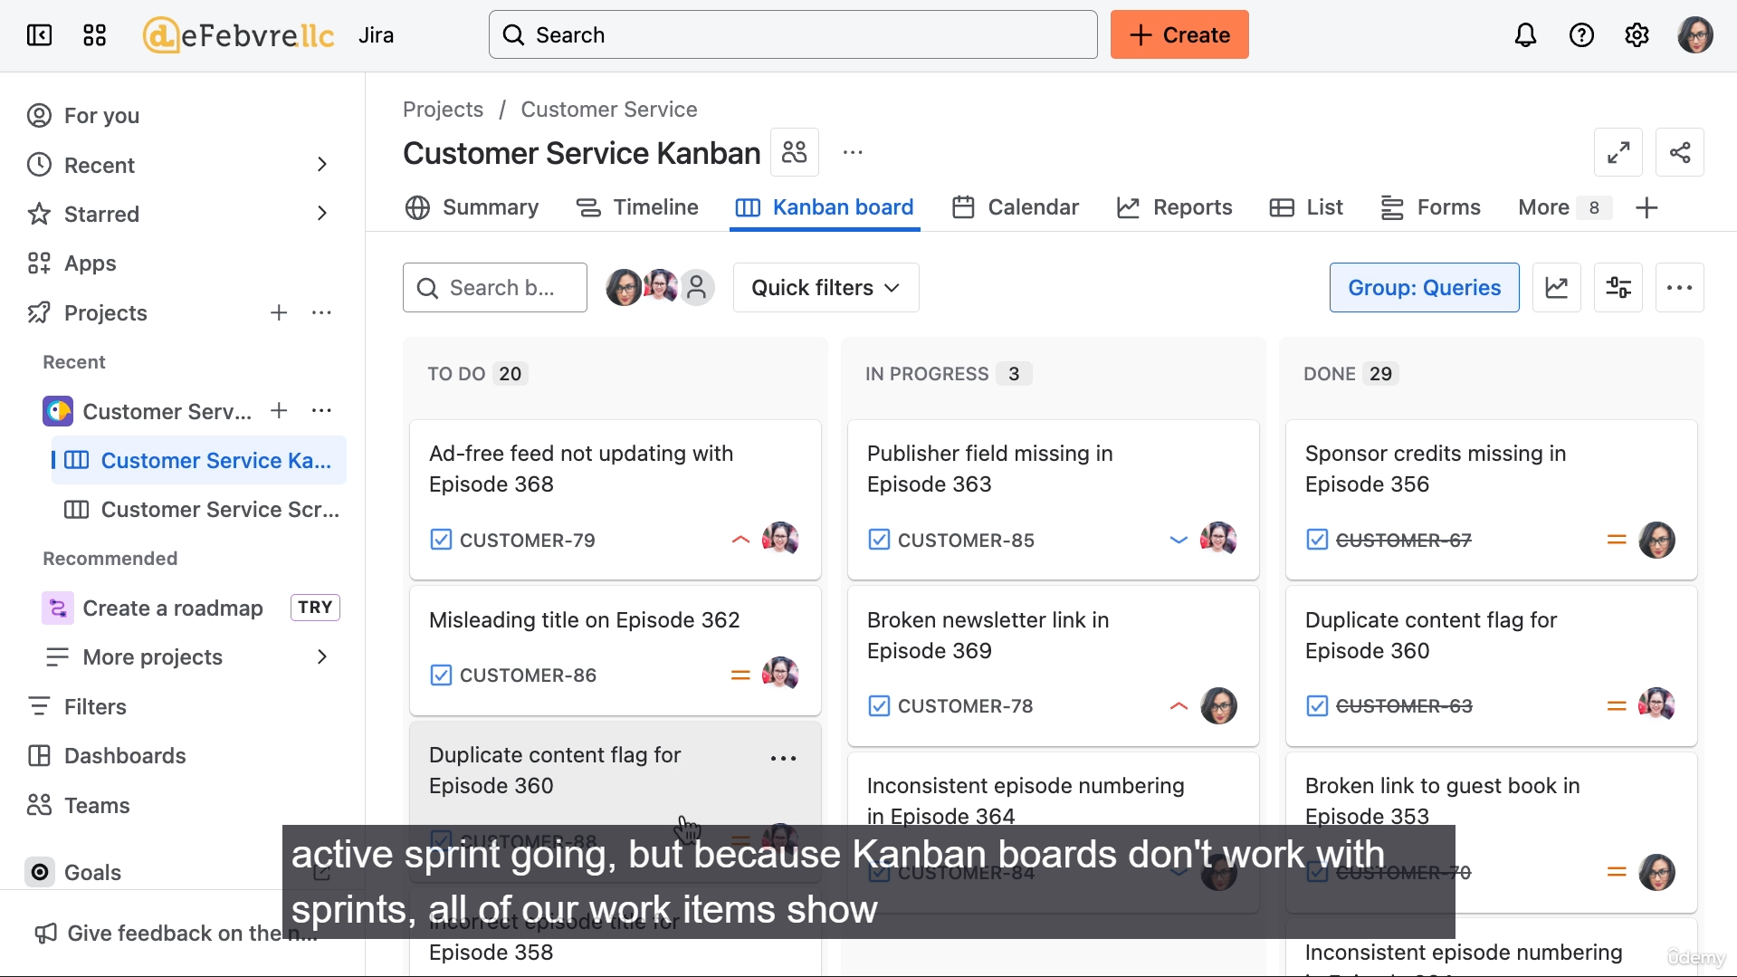

The video introduces the Kanban Agile board in Jira, highlighting the differences from the Scrum board and demonstrating how to customize the board filter and enable an optional backlog.

Here is a summary of the key steps and concepts:

**1. Creating the Kanban Board**

* **Creation:** The process is similar to creating a Scrum board: navigate to the project, click the plus sign (+), and choose to create a new **Kanban** board.
* **Initial View Difference:** Unlike a Scrum board (which is empty until a sprint starts), a Kanban board immediately displays all work items that match its filter because Kanban does not use sprints.
* **No Default Backlog:** By default, in an Agile Kanban workflow, there is no separate "Backlog" view; all work starts in the far-left column of the main board.

**2. Customizing the Board Filter (Defining the Goal)**

The board's goal is to allow the Customer Service team to track work that *they report* but may be *assigned to other teams* in the company. This shows how Scrum and Kanban boards can be used side-by-side (Scrum for the team's internal work, Kanban for tracking external dependencies).

* **Access Filter:** Go to **Board Settings** and edit the **Board Filter** query.
* **Filter Change:** The filter is changed from showing work assigned to the Customer Service Team to showing work **reported by** the team members (Eldora or Helen).
  + The JQL is updated to: Reporter in (Helen, Eldora)
* **Result:** The board now displays a wider range of work items, allowing the Customer Service team to monitor the status of all issues they have created for customers, regardless of who is assigned to fix them.

**Note on JQL Error:** The video highlights that Jira's filter optimization suggestions are not always correct and demonstrates how to manually fix a parentheses error in the JQL query before saving.

**3. Enabling the Kanban Backlog**

While Kanban traditionally does not use a backlog, Jira allows you to add one to better manage the inflow of work.

* **Access Layout:** Go to **Board Settings** > **Layout and Columns**.
* **Enabling the Backlog:** The backlog is enabled by mapping a status to the backlog area. The user drags the **To Do** status into the new **Kanban Backlog** section.
* **Result on Board:**
  + The main board now has a separate **Backlog** view that displays all work items in the "To Do" status.
  + The main board itself only shows columns for work currently in progress (e.g., "In Progress").
  + Moving a work item from the Backlog to an "In Progress" column automatically updates the item's status, moving it to the main board.

**4. Next Steps**

The next video will continue configuring the Kanban board's features.

===================================================================================

* + 1. **Configuring Kanban board:**

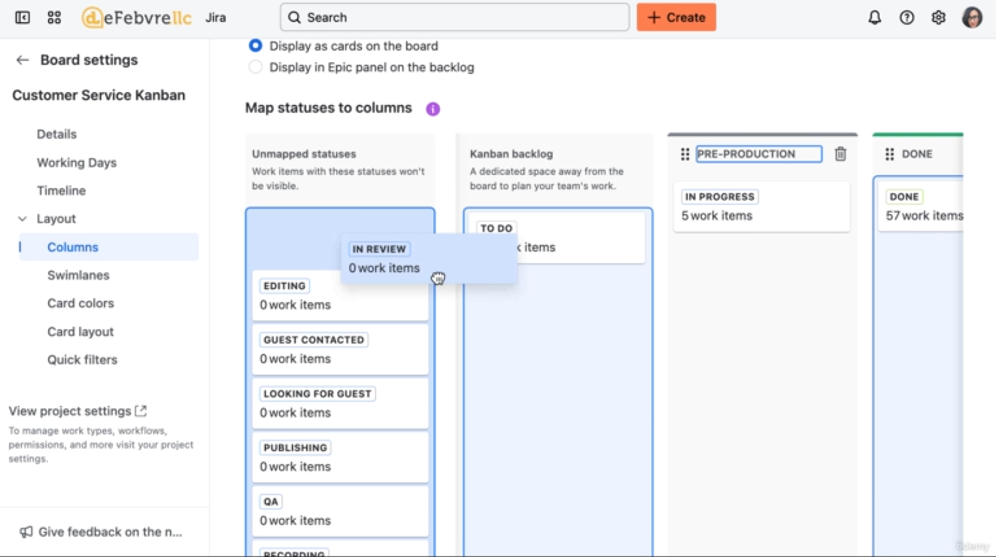

**1. Customizing Board Columns**

The goal is to simplify the visualization of the production process for the Customer Service team, who are using this board to track work they have *reported* to other teams.

* **Access:** Go to **Board Settings** > **Columns** (or Layout and Columns).
* **Column Mapping:** The many unmapped statuses (from various projects in the filter scope) are consolidated into a few, high-level process columns.
* **New Column Structure:**
  + **Backlog:** Mapped to the To Do status (created in the previous video).
  + **Pre-Production:** Mapped to **In Progress** and another status (the example uses two different statuses to represent the first phase).
  + **Production:** Mapped to the **Writing** and **Recording** statuses (representing the actual creation phase).
  + **Post-Production:** Mapped to **In Review**, **QA**, **Editing**, and the **Publishing** process.
  + **Done:** Remains the far-right column, following the left-to-right Agile flow.
* **Result:** The board is simplified into four main stages, providing the Customer Service team with a quick, high-level view of where the reported work stands.

**2. Refining the Board Filter**

The second customization step ensures the board only shows work reported to *other* teams, as the Customer Service team uses their *Scrum* board to track their own work.

* **Access:** Go back to **Board Settings** > **General** and edit the **Board Filter** query.
* **Filter Change:** The filter is adjusted to **exclude** any work items that belong to the Customer Service team's *own project*. This ensures the board is only showing the work they reported that is being handled by others.
* **Result:** The board now accurately reflects its purpose: tracking the status of work items that the Customer Service team has created for other parts of the organization. The majority of the work is still in the "Backlog" or "Pre-Production" columns, which is typical for work that has just been reported.

**3. Next Steps**

The next video will cover the day-to-day workflow and process for working with this newly configured Kanban board.

===================================================================================

* + 1. **Workflow of Kanban Board:**

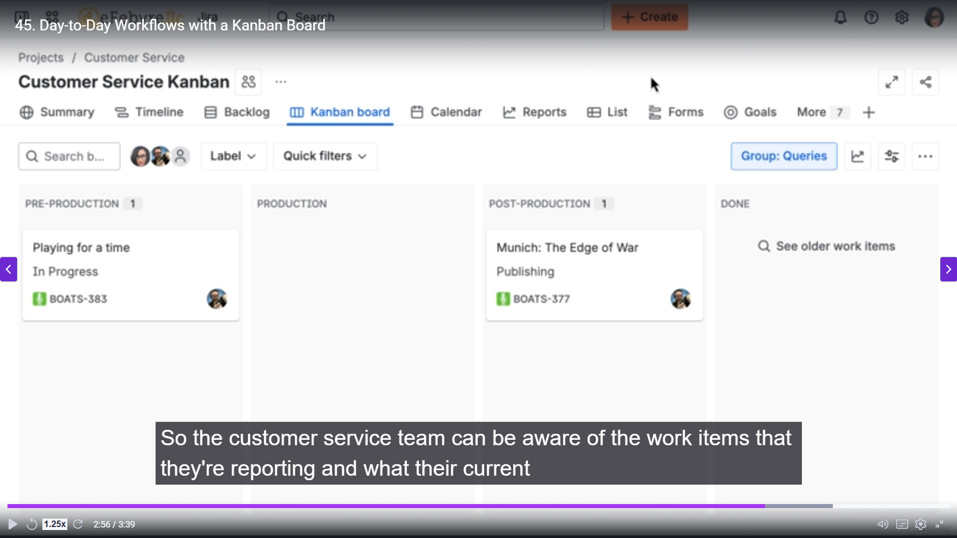

The video focuses on the day-to-day use of the Kanban board, emphasizing its function as a **monitoring tool** for the Customer Service team to track the progress of issues they reported to other production teams.

Here is a summary of the workflow and configuration change:

**1. Kanban Board as a Monitoring Tool**

* **Workflow Refresher:** The Customer Service team (Eldora or Helen) creates a Jira work item when a customer reports an issue or request. This work is then assigned to the specific production team responsible for fixing it.
* **Kanban Board's Role:** The Customer Service team's Kanban board, filtered by issues they *reported*, acts as a single pane of glass to **monitor the status** of all those external work items.
* **Automatic Updates:** When a member of the **Production Team** (logged in on their separate board/workflow) moves a work item to a new status (e.g., from "In Progress" to "Writing"), the status immediately updates on the Customer Service team's Kanban board.
* **Benefit:** The Customer Service team can quickly look at their board to provide updates to customers without needing to actively chase down the production team.

**2. Enhancing the Card Layout**

To make the monitoring role more effective, the configuration is adjusted to display more detail on the work item cards.

* **The Problem:** While the cards are in the "Production" column, the Customer Service team can't see the specific status (e.g., "Writing," "Recording," "Editing") without opening the card.
* **Solution:** Go to **Board Settings** and update the **Card Layout**.
* **Change:** The **Status** field is added to the card layout.
* **Result:** The specific, granular status (like "Writing" or "Editing") now appears directly on the card, even though the card is still in the high-level "Production" column, allowing for clearer monitoring.

**3. Conclusion**

The video concludes the section on Agile boards by encouraging the user to apply the learned Scrum and Kanban concepts to create a custom, efficient workflow tailored to their own team's needs. The next topic will shift to using **Dashboards** in Jira.

===================================================================================

* + 1. **Creating, Sharing and customize dashboards:**

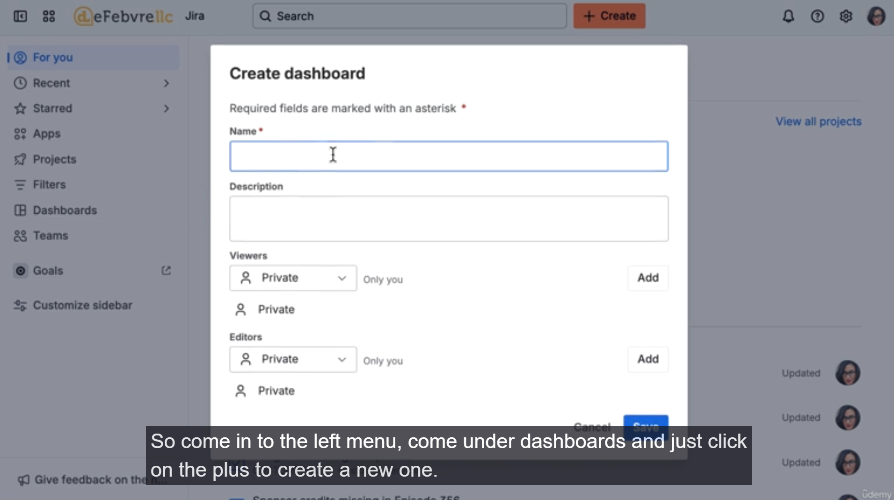

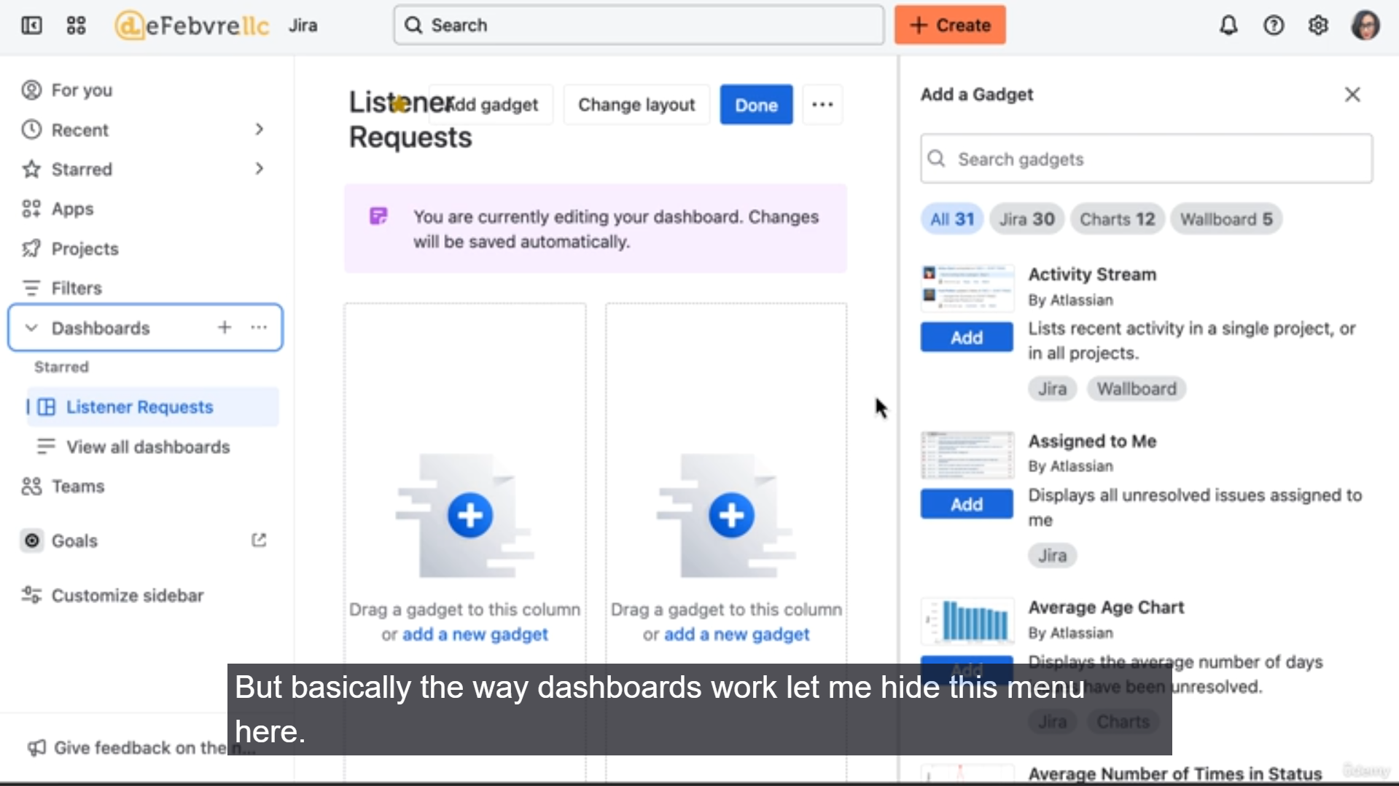

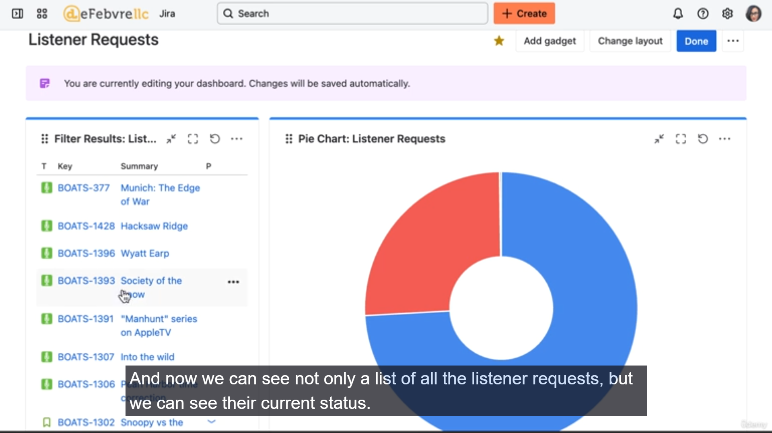

**1. Creating and Sharing a Dashboard**

* **Creation:** Dashboards are created via the left-side menu by navigating to **Dashboards** and clicking the plus sign (**+**).
* **Permissions (Key Concept):** Setting permissions requires you to explicitly **add** the permission level, not just select it.
  + **Viewing Permissions:** You can allow anyone in the organization to view the dashboard, or even make it **public** for the internet (though this is less common).
  + **Editing Permissions:** You can assign editing rights to specific users, groups (legacy feature), or members of a project. The public cannot be granted editing permissions.
  + **Example Setup:** The dashboard is set up so **anyone in the organization can view it**, and anyone in the **Customer Service Project can edit it**.

**2. Customizing with Gadgets**

* **Gadget Function:** Gadgets are the building blocks of a dashboard, each pulling specific data or visualizations. The user is encouraged to explore the wide range of available gadgets.
* **Layout:** The dashboard layout can be adjusted to use one, two, or three columns to organize the gadgets.
* **Filter Results Gadget:**
  + This is one of the most common gadgets.
  + It displays a list of work items that match a specific **Jira Filter** (a saved search).
  + **Example:** A filter called "Listener Request Filter" is hooked up to display all work items tagged as listener requests.
* **Pie Chart Gadget:**
  + This visualizes data from a filter.
  + **Example:** The same "Listener Request Filter" is used, but the chart displays the distribution of requests by their current **Status** (e.g., 74% Done, 25% To Do).
* **Sharing and Editing:** Because permissions were set correctly, another user (Eldora, a member of the Customer Service Project) can view the dashboard and make edits to the gadgets (e.g., simplifying the Filter Results gadget to only show the Summary).

**3. Using Dashboards as Wallboards (Slideshow)**

A powerful feature of Jira dashboards is the ability to automatically cycle through multiple dashboards for display on an office monitor.

* **Configuration:** Click the three dots on the dashboard and select **View as Slideshow**.
* **Setup:**
  + Select the dashboards you want to include in the cycle (e.g., "Listener Requests" and "Work in Progress").
  + Set the **refresh interval** (e.g., 10 seconds).
  + Choose whether to display them in a random order.
* **Wallboard Use:** The slideshow can be opened in a browser and set to full-screen on a TV monitor in the office, providing the team with a real-time, rotating view of key metrics like work status, sprint burn-down, or request volume.

The video concludes by encouraging users to experiment with different gadgets to create relevant reports, before moving on to other Jira reporting tools.

===================================================================================

* + 1. **Reports:**



